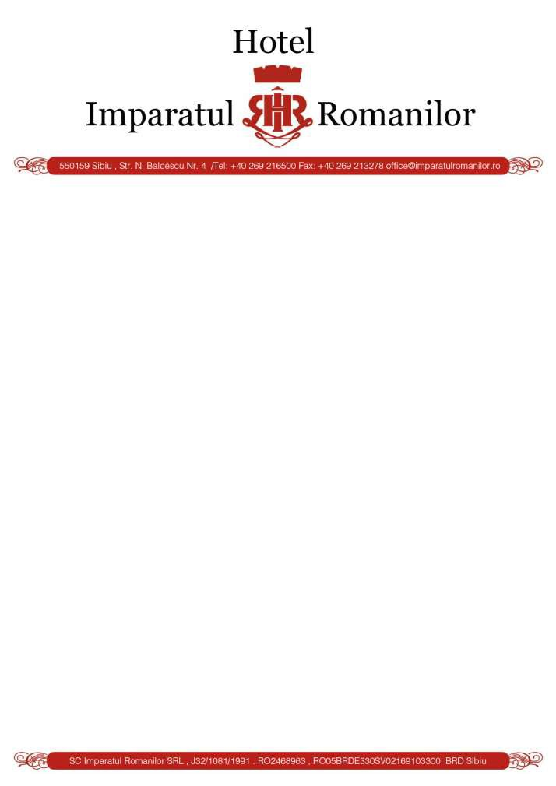

http://sibiu.imparatulromanilor.ro/en/

Hotel Contact : Mr. Stefan Rezeanu

E-mail : sibiu@imparatulromanilor.ro/ office@imparatulromanilor.ro

12-15 Iunie 2019 /June 2019 / Formular de rezervare/reservation form

Reservation Form

EU MACS 12.06.2019-15.06.2019

NAME:

Period:

Room type:

Rates:
- SINGLE - Price: 52 EURO / NIGHT;

- DOUBLE - Price: 62 EURO / NIGHT;

- SUITE DELUXE/ DUPLEX – PRICE: 72 Euro/NIGHT;

- ONE SUITE BEDROOM – PRICE 82 Euro/NIGHT;

  - Breakfast, VAT included, City tax included, free acces to pool and sauna (finnish and turkish sauna), wi-fi high speed
  - Reservations will be made until: 1st May 2019 by email:
office@imparatulromanilor.ro / sibiu@imparatulromanilor.ro
- or fax +40269 216 500 .

Your Sincerely, General Manager Stefan Rezeanu

